**Measuring power outage exposure with simulations**

**Tables and figures:**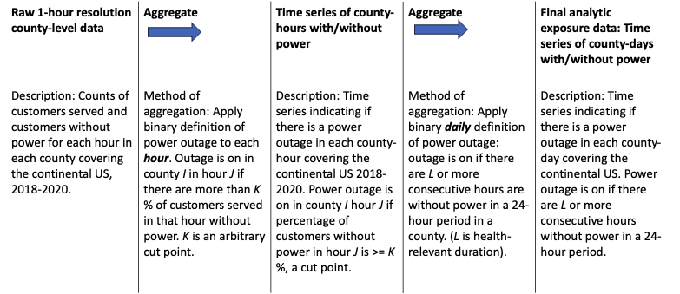

Figure 1: Flowchart describing how the proposed definition of power outage exposure could be applied to the PowerOutages.us data. The raw PowerOutages.us data contains county-level hourly counts of customers without power for all counties in the continental US, 2018-2020, and could be aggregated into daily binary indicators of power outage according to the strategy proposed in the text and outlined in this flowchart. Feedback appreciated!

